Offense vs Defense: which is the key determinant factor of winning in the NBA?

Mirlan Tnaliyev

MA 214 Honors Project

Professor G. Vaughan

Table of Contents

**Introduction****3**

**Data Overview 4**

**Analysis 5**

**Conclusion 10**

**References 11**

**Introduction**

The debate between the importance of offensive and defensive strategies in sports has long been a subject of discussion. Both aspects are undeniably vital components of competitive team sports, with each requiring strong teamwork, an ability to read the game, and an aptitude for anticipating the opposition's moves. However, the question remains: is one truly more important than the other? In basketball, particularly in the NBA, determining the answer to this question holds considerable weight when it comes to crafting team strategies and pursuing championships. For example, the 2004 Detroit Pistons, led by coach Larry Brown, prioritized a defensive mindset and managed to win the NBA championship, defeating the star-studded Los Angeles Lakers. On the other hand, the 2017 Golden State Warriors, with their high-powered offense featuring Stephen Curry, Klay Thompson, and Kevin Durant, also secured an NBA title, showcasing the effectiveness of a strong offensive strategy.

In a high-stakes environment like the NBA, teams are tasked with allocating their limited resources, such as player contracts, draft picks, and training time, as effectively as possible to maximize their chances of success. As such, understanding the nuances of offense and defense and identifying which aspect to prioritize becomes a critical factor in decision-making.

Using NBA data (particularly for the 2022-23 regular season), I will delve into the offense versus defense debate and explore the factors that might potentially contribute to a winning team in professional basketball.

**Data Overview**

I decided to look at the average “Team FG%”, the average “Opponent FG%”, and the “Win%” of all 30 NBA teams over the 2022-2023 regular season.

**Glossary:**

1. **Team FG%** (Field Goal Percentage): This statistic represents the percentage of field goals (both two-point and three-point shots) successfully made by a team in a game or over a season, relative to the total number of field goal attempts. A higher Team FG% indicates better shooting efficiency.
2. **Opponent FG%** (Opponent Field Goal Percentage): This statistic represents the percentage of field goals (both two-point and three-point shots) successfully made by the opposing team in a game or over a season, relative to the total number of field goal attempts. A lower Opponent FG% usually indicates a better defensive performance, as it means the team is successfully limiting the opponent's shooting efficiency.
3. **Win%** (Win Percentage): This statistic represents the proportion of games a team has won over a specified period (in this case, the 2022-2023 regular season) relative to the total number of games played. Win% is calculated by dividing the number of games won by the total number of games played and is often expressed as a percentage. A higher Win% indicates better overall team performance and success in the season.

**Analysis**

Before performing a main part of the analysis, I decided to look at how these teams ranked in the 2022-2023 regular season for the aforementioned categories and visualize the data.

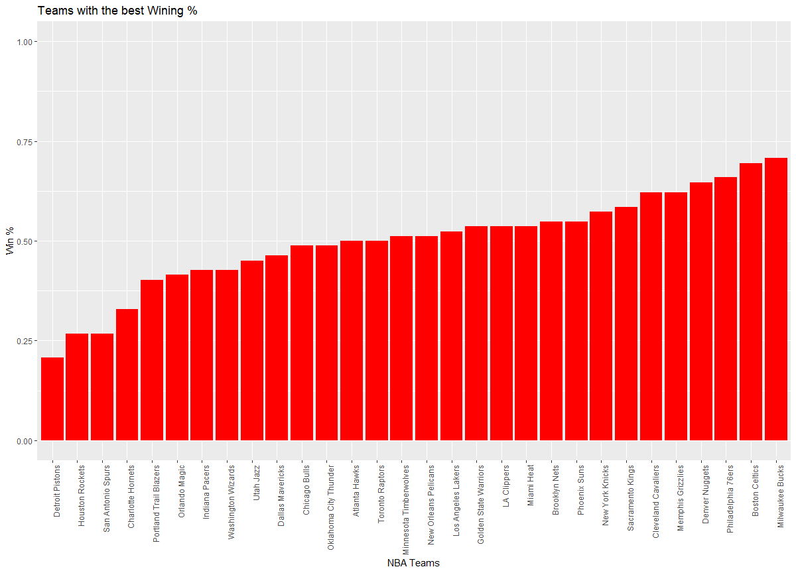

*Figure 1. Teams rankings according to their Winning % (in ascending order)*

Interesting to see that 12 out of 30 teams win less than 50% of their games. It was unexpected for teams, such as the Dallas Mavericks and OKC Thunders, as without this data, they seemed to perform quite well during the season. Milwaukee Buck leads in this category while Detroit Pistons have won the least games throughout the season.

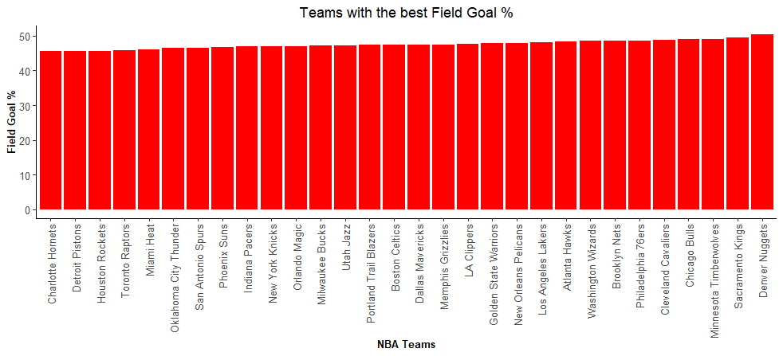

*Figure 2. Teams rankings according to their Field Goal % (in ascending order)*

The data for FG% across all teams are quite similar, however, Denver Nuggets has outperformed every other team in this statline while Charlotte Hornets is ranked the last along with Detroit Pistons and Houston Rockets.

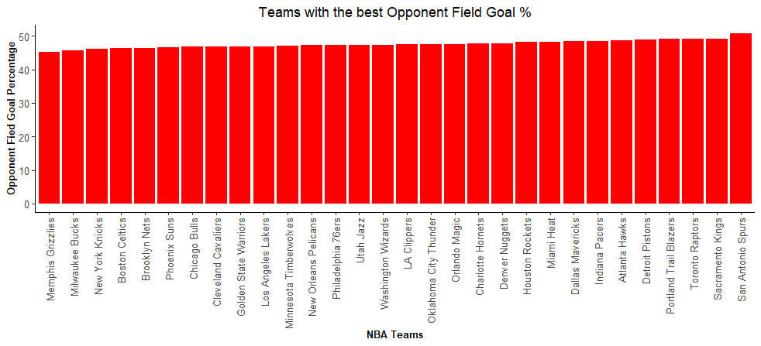

*Figure 3. Teams rankings according to their Opponent Field Goal % (in ascending order)*

The data for Opponent FG% across all teams are quite similar too, however, San Antonio Spurs has outperformed every other team in this statline while Memphis Grizzlies is ranked the last in this category.

Afterwards, I performed the normal probability plot of residuals to check the assumption of normality of residuals in a regression analysis. The normality of residuals is a crucial assumption, as it ensures the validity of statistical tests and confidence intervals associated with the regression coefficients. We can see that our plot is relatively normal with a few outliers.

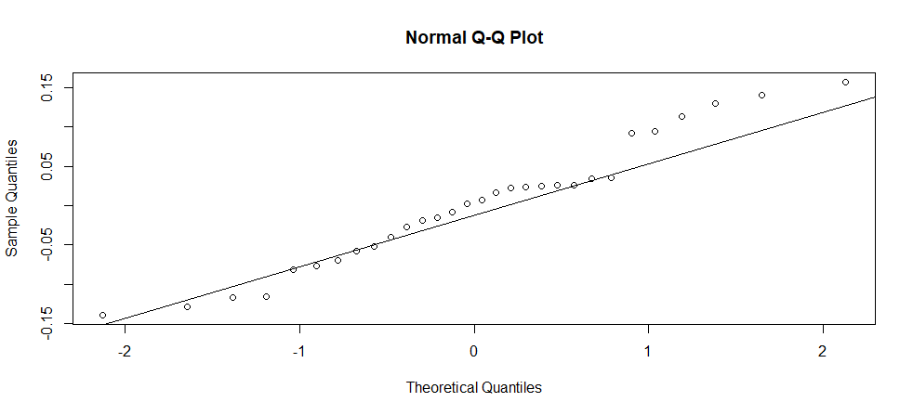

*Figure 4. Normal probability plot of residuals*

I conducted a multiple regression analysis to determine the importance of a strong offense or a solid defense in enhancing a team's overall performance. The results of the primary multiple regression analysis will be obtained using the built-in linear model function 'lm()' in R. In this analysis, I marked “WinPercentage” as the response variable, and “TeamFGPercentage” and “Opponent FG Percentage” as the predictor variables.

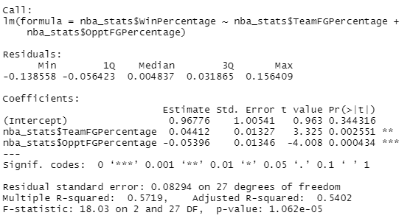

*Figure 5. Regression Analysis Output*

I also calculated the VIF value to get more reliable estimates of the regression coefficients and avoid issues when it comes to estimating the true relationship between the independent variables and the dependent variable. It ended up being that



*Figure 6. VIF Value Output*

By looking at our Regression Output, I claim that our linear regression model has shown to be **defensible.** Our p- values for Team FG% and Opponent FG% were 0.00255 and 0.00043 respectively. The p-values suggest that both Team FG% and Opponent FG% have a statistically significant impact on a team's Win% as they are both less than the significance level of 0.05

Our adjusted R-squared = 0.54; an adjusted R-squared value of 0.54 indicates that approximately 54% of the variation in Win% can be explained by the Team FG% and Opponent FG% variables. The remaining 46% of the variation in Win% is due to other factors not included in the model. This implies that these two variables are important factors in predicting a team's success, but there are still other factors that could further explain the variation in Win%. Our VIF Value output also has shown 1.067 for both predictor variables.

The model for our Regression Model looks the following:

**Win %** = 96.776 + 4.412 * **Team FG%**  - 5.396 * **Opponent FG%**

I also went further and created a 3D plot of the regression plane along with the data points. By plotting it, I can assess how well the linear regression model fits the data. There is a chance that the plane doesn't fit the data points well, it may indicate that the model is not accurately capturing the relationship, and further investigation or model adjustments may be necessary. As a result of this, the model has been claimed to capture the underlying relationship between the variables.

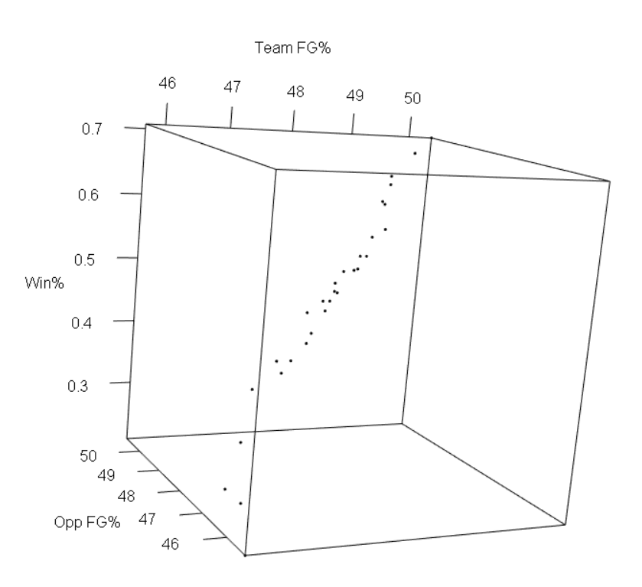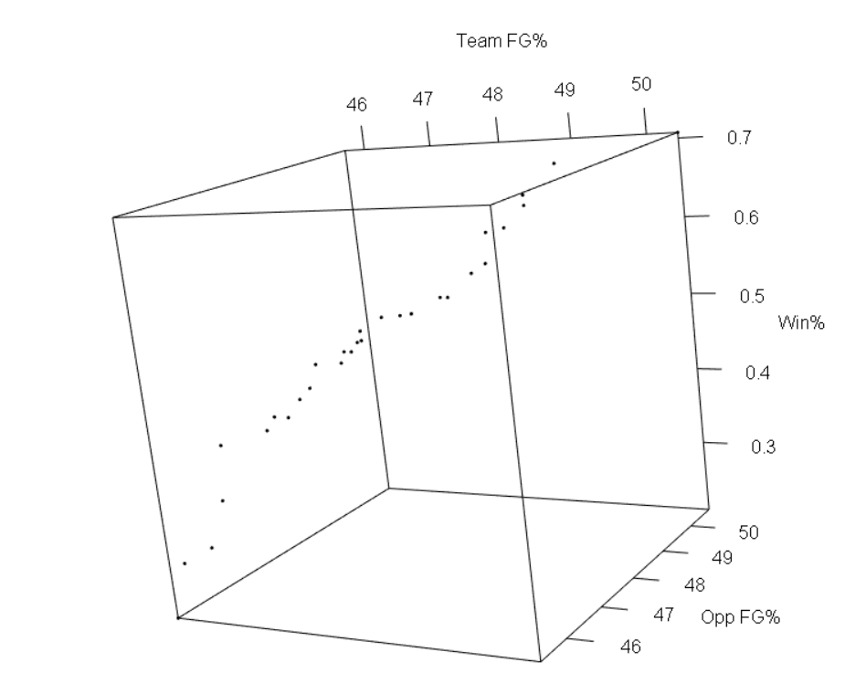

*Figure 7. 3D Plots between the variables*

**Conclusion**

The analysis I conducted demonstrated that the model was valid for determining Win%. I found that the coefficients for Team FG% and Opponent FG% were 4.41 and 5.4, respectively, indicating that Opponent FG% had a stronger influence on Win% than Team FG%. This suggests that a team's defensive performance, as measured by the Opponent FG%, plays a more significant role in determining the team's success compared to its offensive performance, as measured by the Team FG%. However, it's important to note that the data points considered in this report don't account for numerous other factors that could influence the outcomes, such as home versus away games, shot types (2-point versus 3-point), active players, and more. Investigating these additional aspects could provide further insights into the dynamics of winning games in basketball.

**References**

(n.d.). The official site of the NBA for the latest NBA Scores, Stats & News. | NBA.com. Retrieved May 5, 2023, from <https://www.nba.com/>

*Is Defense More Important than Offense in Basketball? | Coach Walter Carvalho – PhD Hoops*. (n.d.). PhD Hoops. Retrieved May 5, 2023, from <https://www.phdhoops.com/is-defense-more-important-than-offense-in-basketball/>